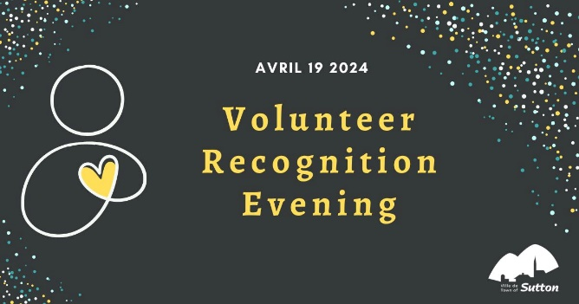
APPLICATION FORM
Volunteer Recognition Evening
by the City on April 19, 2024

The organizations recognized by the Town of Sutton are therefore invited to individually submit the candidacy of a volunteer of their choice, using the form below, before March 29 2024 at 4:30 p.m.

Once completed, you can send it by email to the following address: agculture.lvc@sutton.ca or by dropping it off at the Town Hall reception desk or by slipping it in the mail chute which is located to the right of the Town Hall entrance door.

APPLICANT ORGANIZATION
Organisation’s name
Name of the contact person
Phone number
Email

We will contact this person to inform them of the details of the event.

CATEGORY Check the appropriate box
Recreation and sports | This category is for a person who has volunteered to consolidate, develop or promote a sport or leisure activity in the Suttonnais community
Community Life | This category is for an individual who has contributed voluntarily to the social development of the Suttonnian community.
Culture | Cette catégorie s’adresse à une personne qui a œuvré bénévolement à la consolidation, au développement ou au rayonnement d’une pratique artistique ou du milieu culturel auprès de la communauté suttonaise.
Emerging: volunteer of 30 years old or less | This category recognizes the involvement of volunteers under the age of 30 for their contribution to social and community life.

VOLUNTEER SELECTED BY THE ORGANIZATION
Name
Age
Number of years of involvement
Number of volunteer hours per week
Nature and impact of its involvement - tasks
Recognized qualities
Describe this person in one sentence
Tell an anecdote that represents this person well
Why did you choose him or her?
Other comments

IF POSSIBLE, ATTACH A PHOTO OF THE VOLUNTEER TO YOUR FORM/EMAIL.

